**Project Proposal**



**Session: 2021**

**Submitted by:**

**Muhammad Labeeb Tariq 2021-SE-15**

**Numan Ahmad 2021-SE-24**

**Wali Muhammad Ahmad 2021-SE-39**

**Numan Danish 2021-SE-49**

**Farjad Waseem 2021-SE-56**

**Submitted to:**

**Dr. Umer Qasim**

Department of Computer Science,

**University of Engineering and Technology, New Campus Lahore**

Table of Contents

Personal Finance Tracker 3

Introduction: 3

Objectives: 3

Scope: 3

Key Features: 3

Deliverables: 3

Timeline: 4

WBS (Work Breakdown Structure) 4

Tools and Technologies: 4

Team Roles and Responsibilities: 5

Risk Analysis and Risk Management 5

Risk Management Plan 7

Conclusion: 7

# Personal Finance Tracker

## Introduction:

In today’s fast-paced world, managing personal finances effectively is crucial for financial stability and growth. Personal Finance Tracker is a mobile application designed to help users manage their expenses, create budgets, and track savings in a simple and easy way. This project aims to deliver a functional prototype of the app, focusing on two key features: expense tracking and budget creation.

## Objectives:

1. To develop easy to use mobile app that helps individuals manage their personal finances.
2. To provide features for tracking expenses, creating budgets, and monitoring savings goals.
3. To ensure the app is accessible, secure, and easy to use for a wide range of users.

## Scope:

The project will focus on the following key features:

1. **Expense Tracking:** Users can log daily expenses and categorize them for better insights.
2. **Budget Creation:** Users can set monthly budgets and receive notifications when they are close to exceeding them.
3. **Savings Tracking:** Users can set savings goals and track their progress over time.

## Key Features:

1. Simple and easy to use interface.
2. Secure login and data encryption for user privacy.
3. Budget monitoring updates and notifications for exceeding budgets and savings goals.
4. Reports and visualizations (e.g., charts and graphs) for financial insights.

## Deliverables:

1. Project proposal document.
2. Work Breakdown Structure (WBS).
3. Gantt chart for scheduling and planning.
4. Risk management plan.
5. Working prototype with expense tracking and budget creation features.
6. Final presentation.

## Timeline:

The project will be completed over 20 weeks, with milestones for each phase (e.g., planning, design, development, testing, and delivery).

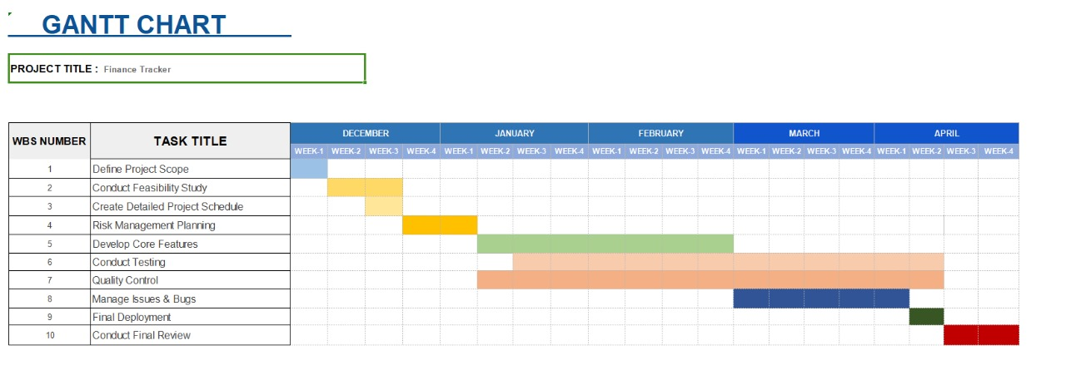

## WBS (Work Breakdown Structure)

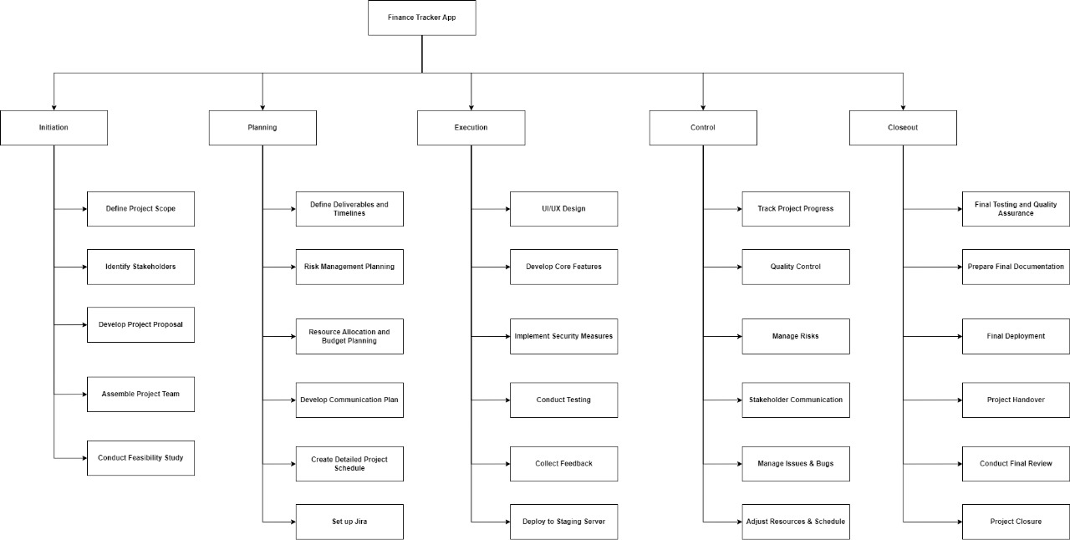

## Tools and Technologies:

1. **Development:** Flutter (for cross-platform mobile app development).
2. **Firebase:** (For persistent storage).
3. **Project Management:** Jira Software for task management, sprint planning, and progress tracking.
4. **Version Control:** Git for version control and GitHub for code management and collaboration.

## Team Roles and Responsibilities:

1. **Project Manager:** Oversees the project, ensures timelines are met, and manages communication.
2. **Developers:** Responsible for coding and implementing the app’s features.
3. **Designer:** Creates the UI/UX design and prototypes.
4. **Tester:** Ensures the app is bug-free and meets quality standards.
5. **Documentation Specialist:** Prepares project reports and documentation.

## Risk Analysis and Risk Management

1. **Scope Creep (Growing Scope):**
   * **Description:** Uncontrolled changes or continuous growth in the project scope without adjustments to time, budget, or resources.
   * **Impact:** Delays, increased costs, and potential failure to meet deadlines.
   * **Mitigation:**
     + Clearly define the project scope in the proposal.
     + Implement a formal change control process to evaluate and approve any scope changes.
     + Regularly review and communicate project progress with stakeholders.
2. **Technical Challenges:**
   * **Description:** Difficulties in implementing certain features or integrating different technologies.
   * **Impact:** Delays in development and potential compromise on functionality.
   * **Mitigation:**
     + Conduct thorough research and feasibility studies during the planning phase.
     + Allocate buffer time for unexpected technical issues.
     + Ensure the team has the necessary skills or provide training.
3. **Resource Constraints:**
   * **Description:** Limited availability of team members, tools, or budget.
   * **Impact:** Delays, reduced quality, or incomplete deliverables.
   * **Mitigation:**
     + Plan resource allocation carefully using tools like Gantt charts.
     + Prioritize tasks and focus on critical features first.
     + Communicate with stakeholders to secure additional resources if needed.
4. **Schedule Delays:**
   * **Description:** Tasks taking longer than expected to complete.
   * **Impact:** Missed deadlines and potential project failure.
   * **Mitigation:**
     + Use Agile methodologies to break tasks into smaller, manageable sprints.
     + Monitor progress regularly using Jira dashboards and burndown charts.
     + Identify and address bottlenecks early.
5. **Poor Communication:**
   * **Description:** Lack of clear communication within the team or with stakeholders.
   * **Impact:** Misaligned goals, misunderstandings, and delays.
   * **Mitigation:**
     + Hold regular team meetings and status updates after every sprint.
     + Use collaboration tools like Jira and Slack for transparent communication.
     + Document all decisions and share them with the team.
6. **Quality Issues:**
   * **Description:** The prototype or final product not meeting quality standards.
   * **Impact:** Poor user experience and negative feedback.
   * **Mitigation:**
     + Implement a robust testing process, including unit testing, integration testing, and user acceptance testing.
     + Conduct regular code reviews to ensure quality.
     + Gather feedback from users during the prototyping phase.
7. **Stakeholder Misalignment:**
   * **Description:** Stakeholders having different expectations or priorities.
   * **Impact:** Conflicts and dissatisfaction with the final product.
   * **Mitigation:**
     + Engage stakeholders early and often to align expectations.
     + Use prototypes and demos to gather feedback and ensure alignment.
     + Document and communicate project goals and progress clearly. (Project Proposal, Project Charter. etc)
8. **Security Risks:**
   * **Description:** Vulnerabilities in the app that could compromise user data.
   * **Impact:** Loss of user trust and potential legal issues.
   * **Mitigation:**
     + Implement secure coding practices and data encryption.
     + Conduct regular security audits and penetration testing.
     + Stay updated on the latest security threats and best practices.

## Risk Management Plan

1. **Risk Identification:**
   * Brainstorm potential risks with the team during the planning phase.
   * Use historical data and lessons learned from similar projects.
2. **Risk Assessment:**
   * Evaluate the likelihood and impact of each risk.
   * Prioritize risks based on their severity.
3. **Risk Mitigation Strategies:**
   * Develop specific actions to reduce the likelihood or impact of each risk.
   * Assign responsibility for managing each risk to a team member.
4. **Risk Monitoring:**
   * Regularly review and update the risk register throughout the project.
   * Use Jira to track and manage risks as part of the project workflow.
5. **Contingency Planning:**
   * Prepare backup plans for high-priority risks.
   * Allocate contingency time and budget to address unforeseen issues.

## Conclusion:

The Personal Finance Tracker project aims to address the growing need for effective personal finance management through a user-friendly and secure mobile application. By focusing on key features such as expense tracking, budget creation, and savings monitoring, the app will empower users to take control of their financial health. Throughout the project, we have applied essential software project management practices, including Work Breakdown Structure (WBS), scheduling, risk management, and Agile methodologies, to ensure timely and successful delivery.

The use of tools like Jira Software has enabled efficient task management, sprint planning, and progress tracking, while the development of a functional prototype has demonstrated the feasibility and potential of the app. By identifying and mitigating risks such as scope creep, technical challenges, and resource constraints, the team has proactively addressed potential obstacles to ensure project success.